**Bakery table**

In the bakery table admin can add a bakery by clicking “add” button and then admin can enter a data related to the bakery. Same as admin can update that bakery’s data when something change, and delete it but when admin click on delete it will give him a message that are you sure you want to delete this? And when admin clicks ok then that bakery would be deleted.

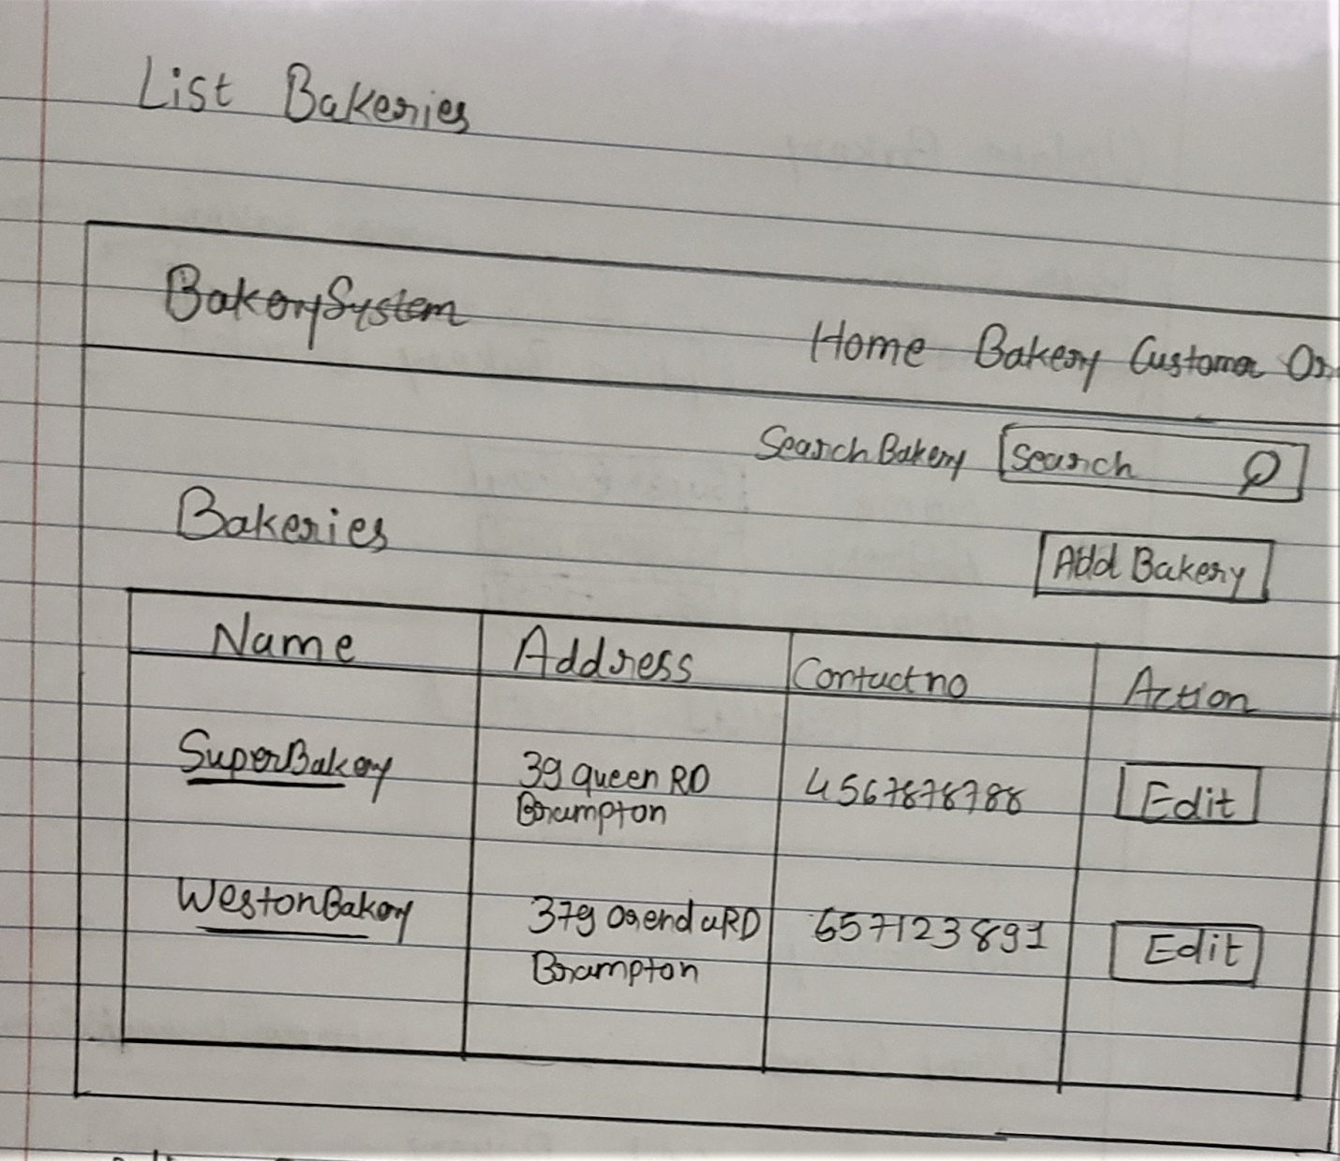

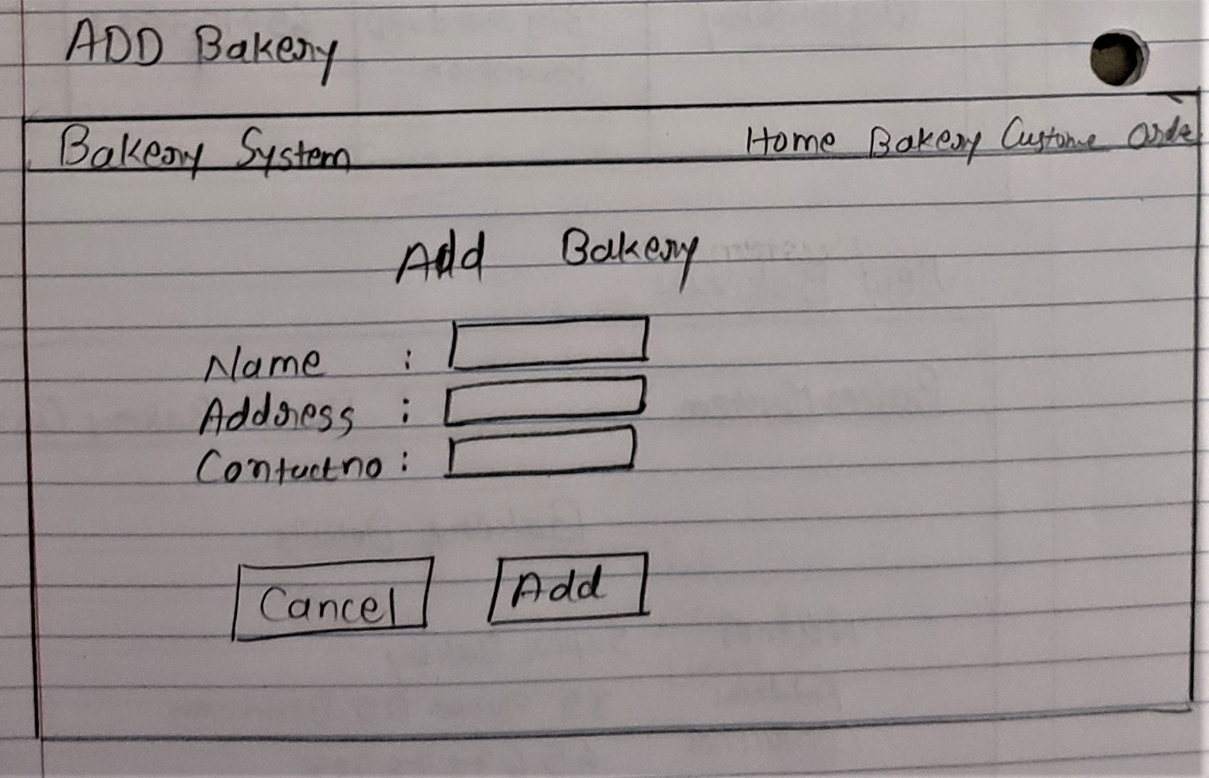

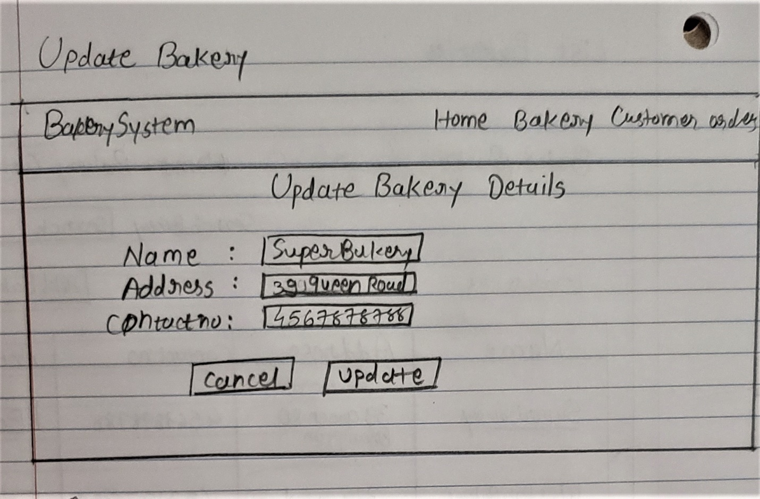

The show view for admin is as shown below when admin want to search for the bakery he can type the name of that bakery in the search bar and the name will show up. When admin get that particular bakery what he want to see then he can click on that bakery and it will show the details of that particular bakery. Though the bakery can have many customers so on that page admin can see the list of customer who visited that bakery. (By using many to many relationship)

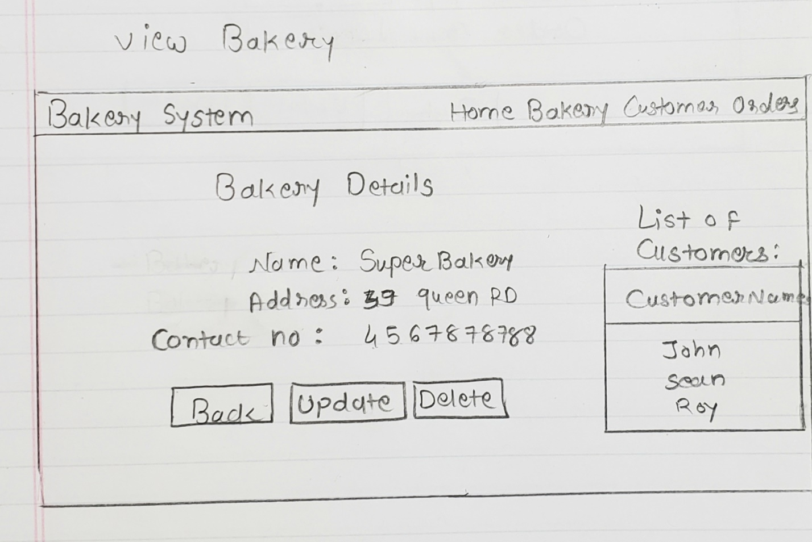

**Customer table**

In the customer table admin can add a customer by clicking “add” button and then admin can enter a data related to the customer. Same as admin can update that customer’s data when something change ,and delete it but when admin click on delete it will give him a message that are you sure you want to delete this customer? And when admin clicks ok then that customer’s data would be deleted.

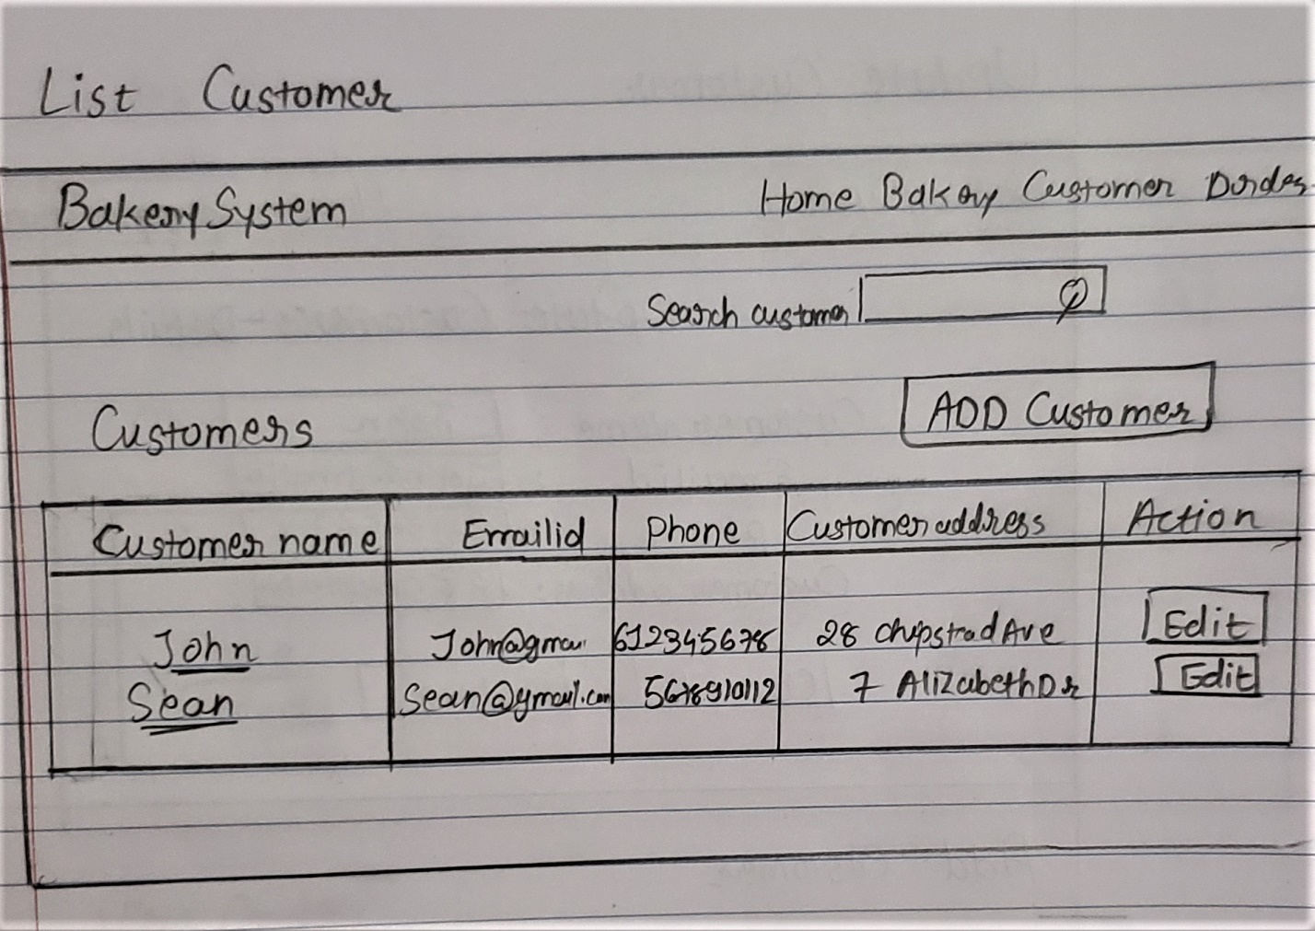

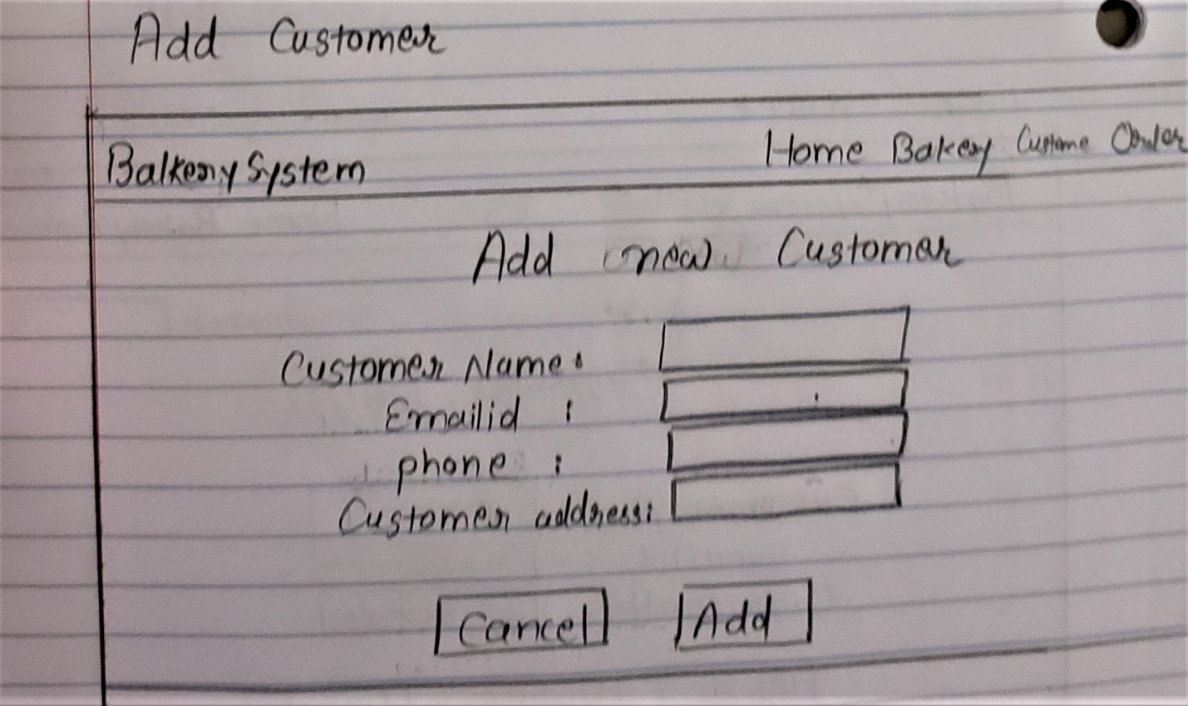

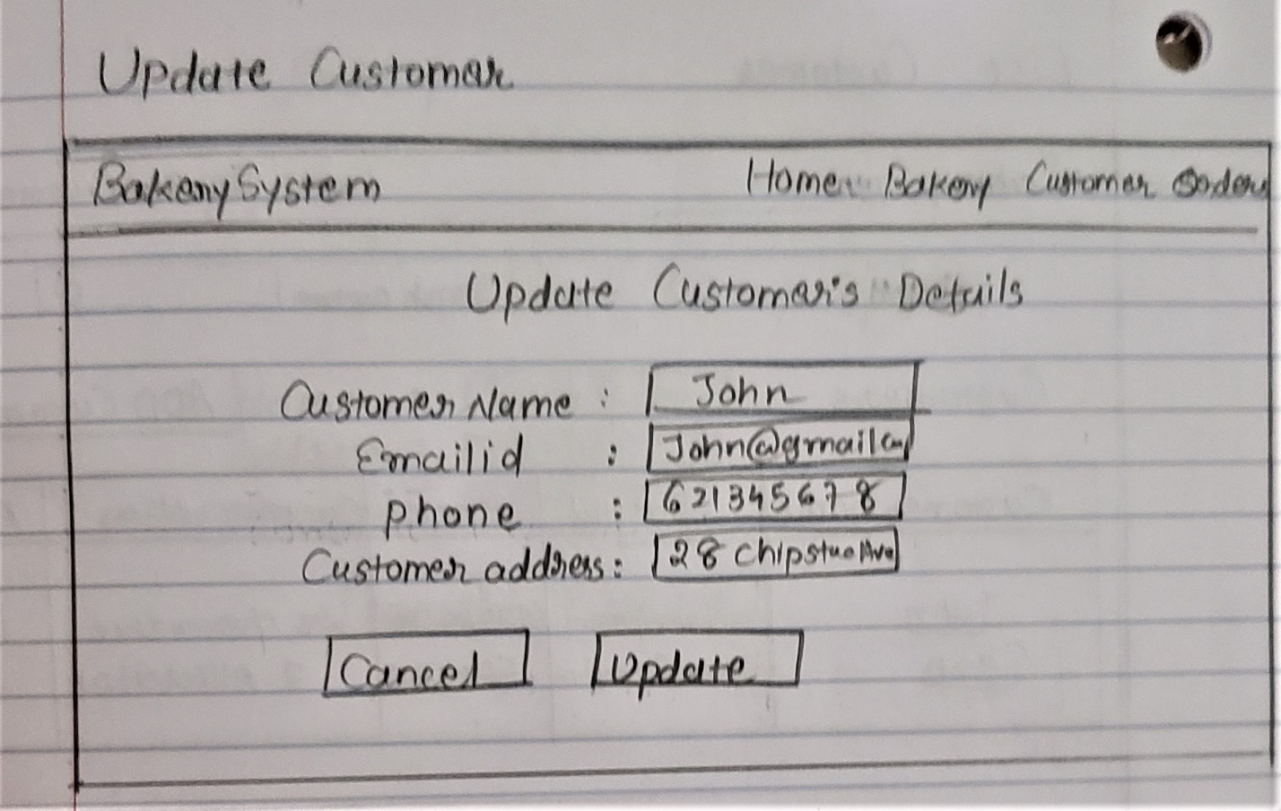

The show view for admin is as shown below when admin want to search for the customer he can type the name of that customer in the search bar and the name will show up. When admin get that particular customer what he want to see then he can click on that customer name and it will show the details of that particular customer. Though the customer can visit many bakeries so on that page admin can see the list of bakeries which is visited by the customer, (By using many to many relationship) and also a customer can do many orders so admin can see the list of how many orders that customer has ordered.

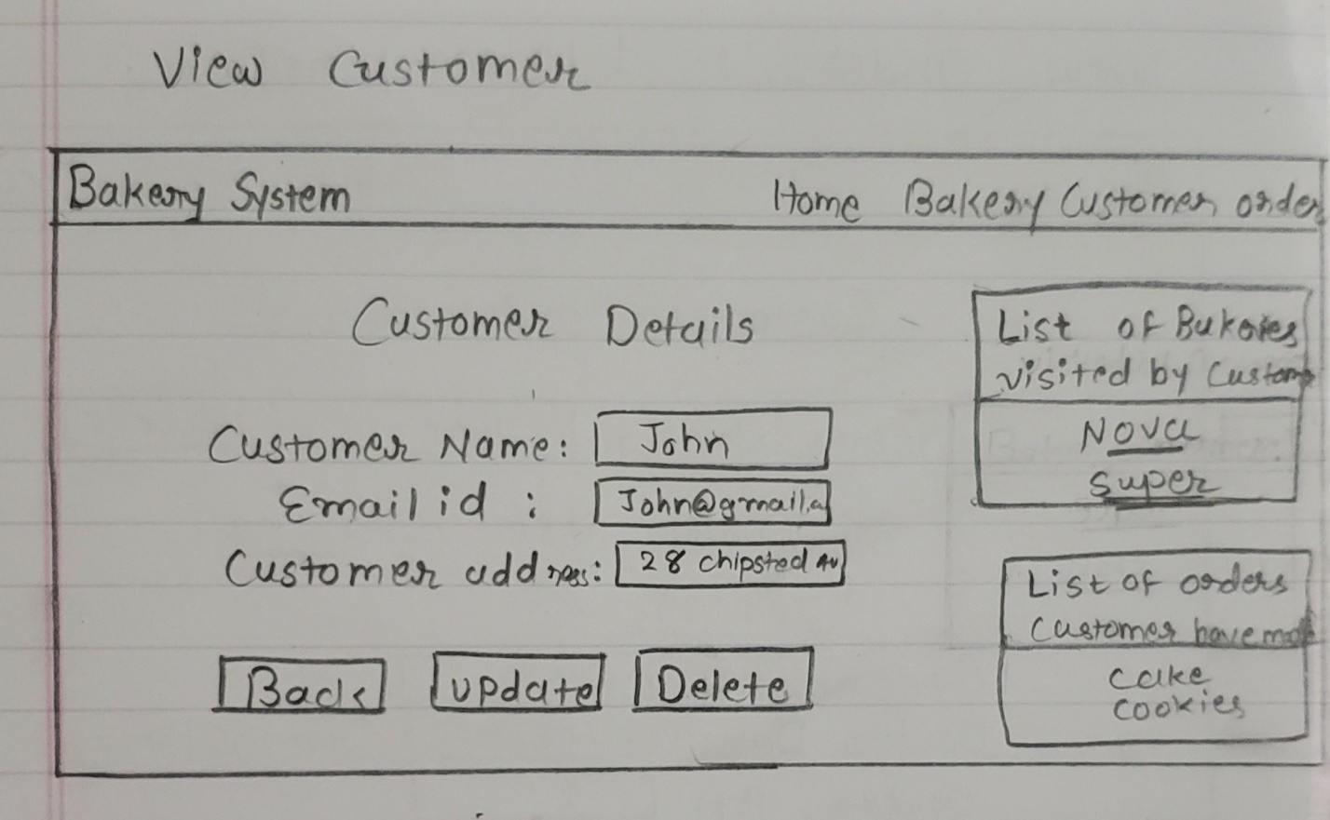

**Order table**

In the order table admin can add an order by clicking “add” button and then admin can enter a data of that order. Same as admin can update that order’s data when something change, and delete it but when admin click on delete it will give him a message that are you sure you want to delete this order? And when admin clicks ok then that order’s data would be deleted.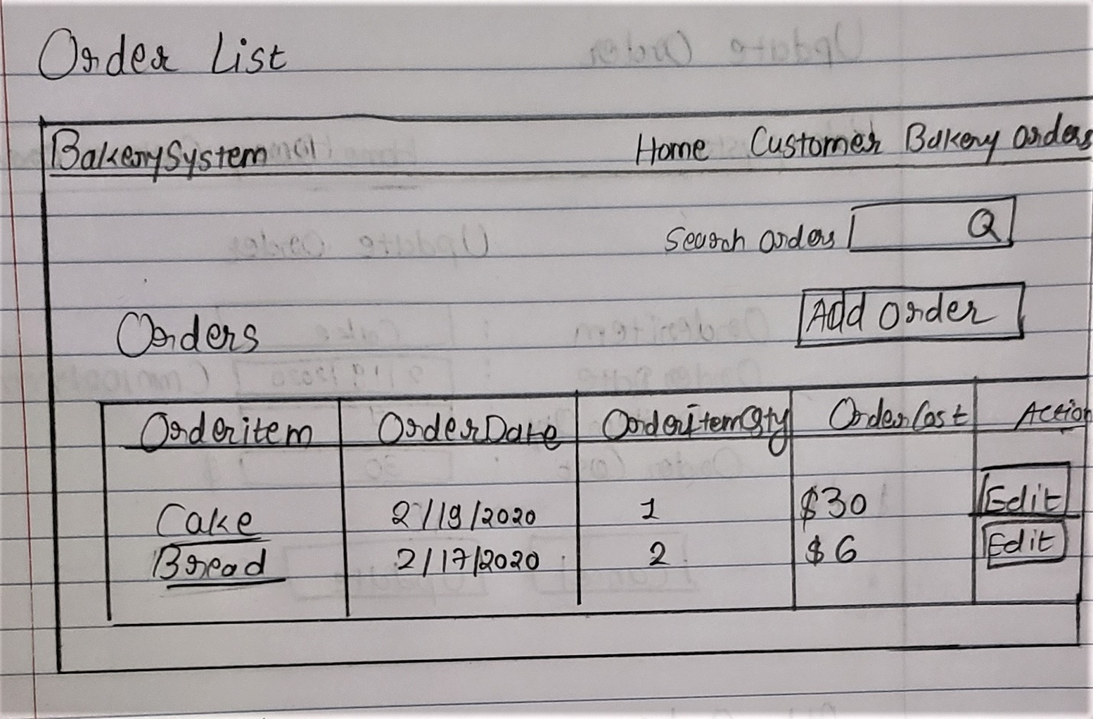

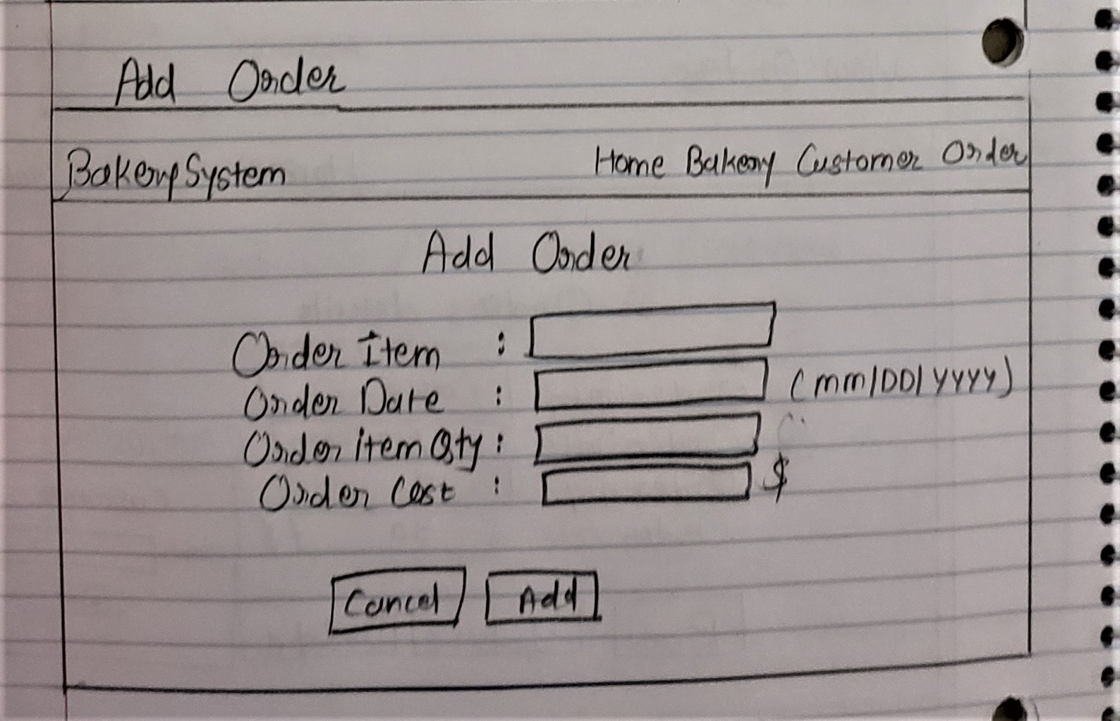

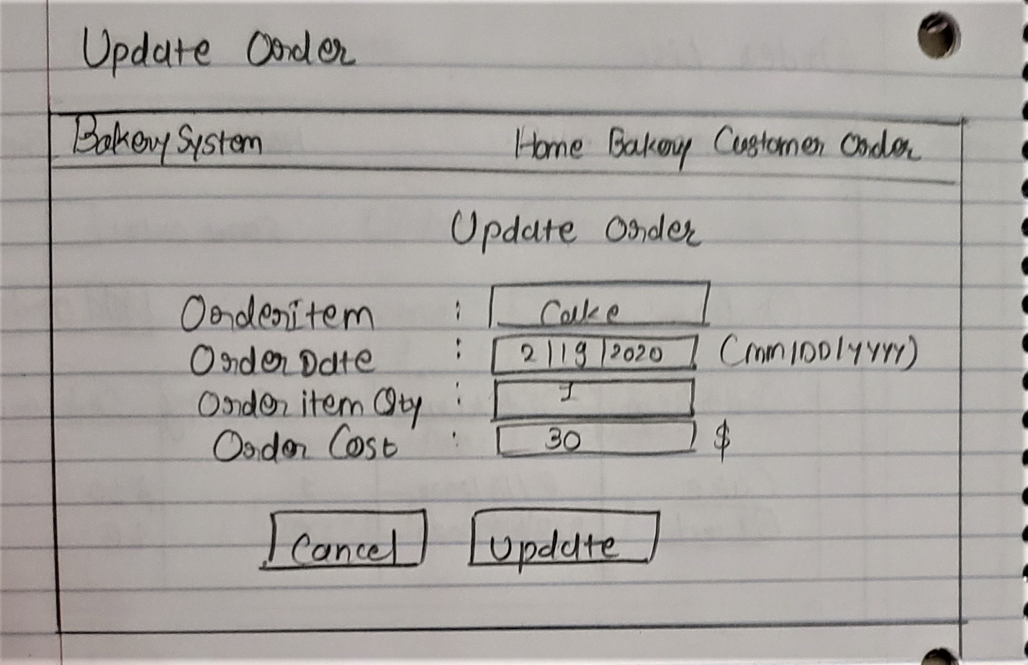

The show view for admin is as shown below when admin want to search for the order he can type the name of that order in the search bar and the name will show up. When admin get that particular order what he want to see then he can click on that order name and it will show the details of that particular order. Though one order can be ordered by many customers so on that page admin can see the list of customers which has ordered same by the order name, (one to many relationship)

